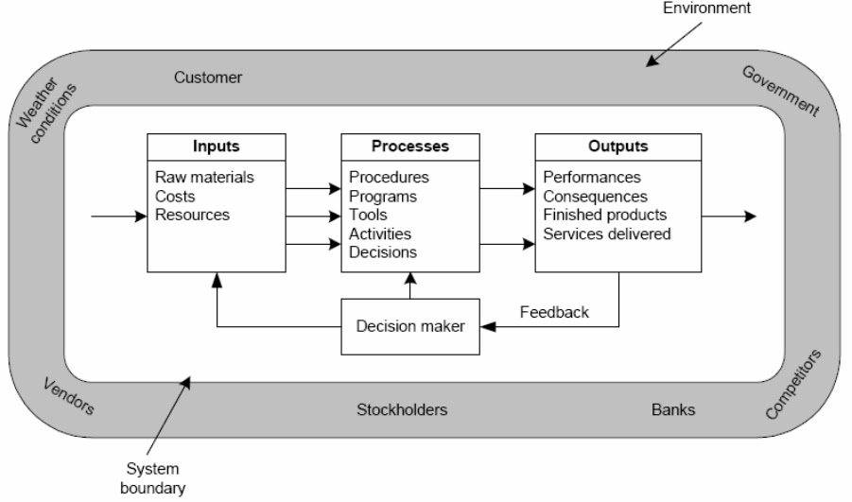DIAGRAM FLOWCHART

1. Gambar sistem dan lingkungan hal 9

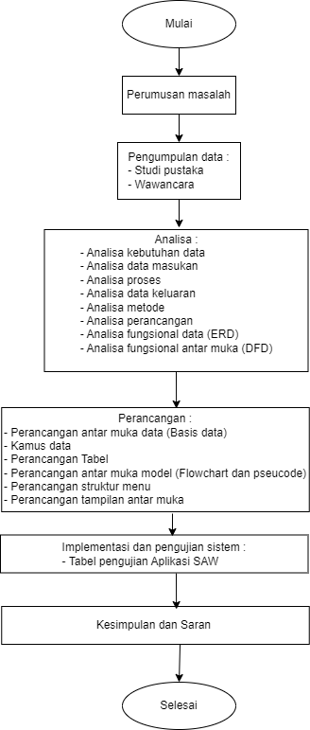

1. Flowchart penelitian hal 28

|  |  |  |  |  |  |  |  |  |  |  |
| --- | --- | --- | --- | --- | --- | --- | --- | --- | --- | --- |
| No | Kegiatan | Bulan | | | | | | | | |
|  |  | September 2022 | | | November 2022 | | | Januari 2024 | | |
| 13 | 14 | 15 | 18 | 19 | 20 | 27 | 28 | 29 |
| 1 | Pengajuan judul |  |  |  |  |  |  |  |  |  |
| 2 | Surat riset |  |  |  |  |  |  |  |  |  |
| 3 | Pengumpulan data |  |  |  |  |  |  |  |  |  |
| 4 | Analisis |  |  |  |  |  |  |  |  |  |

3 Tabel waktu penelitian hal 38

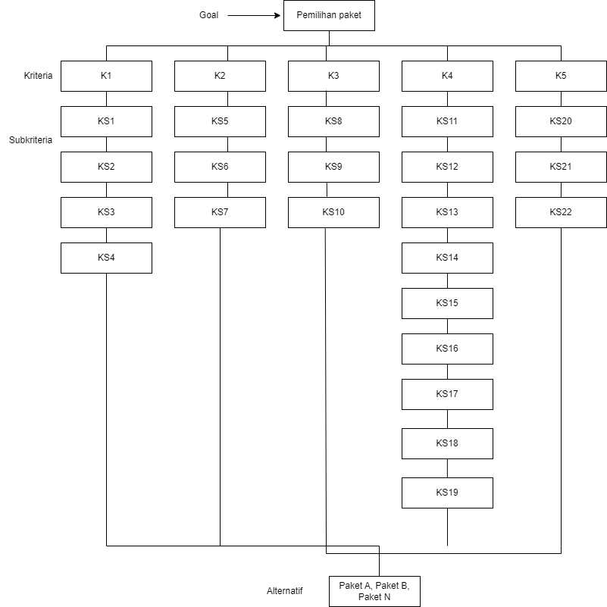

Struktur hirarki halaman 46

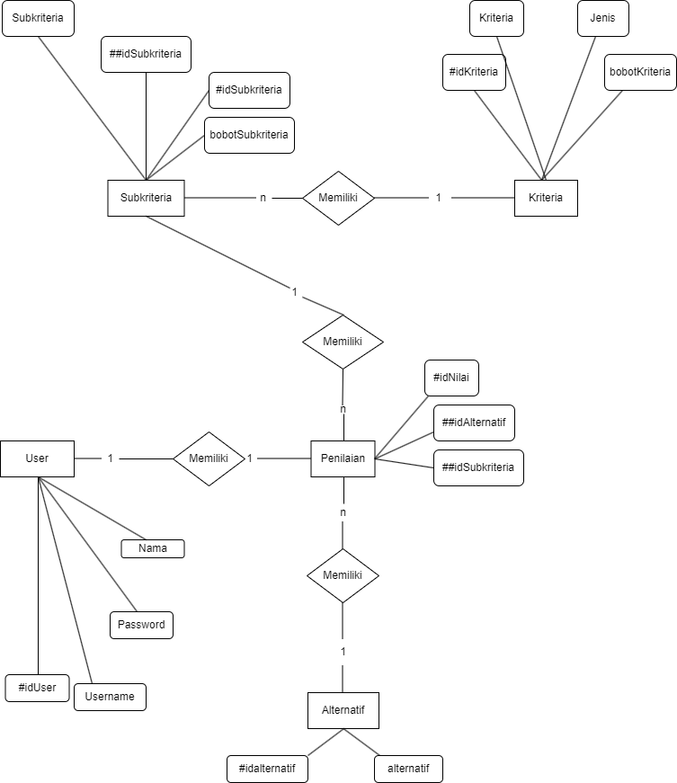

Revisi erd hal 54

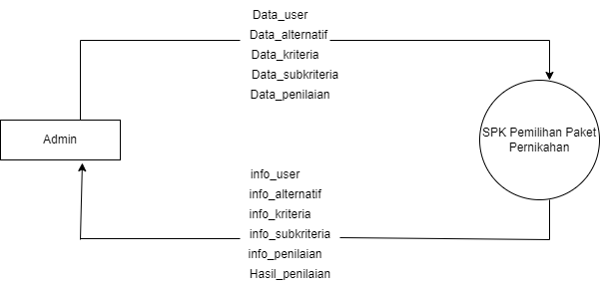

Revisi dvd lv0 hal 56

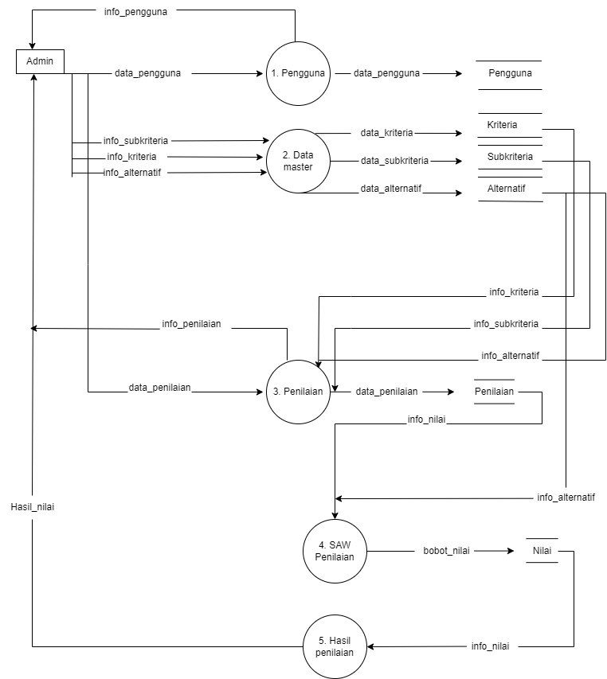

Revisi DFD level 1 hal 57

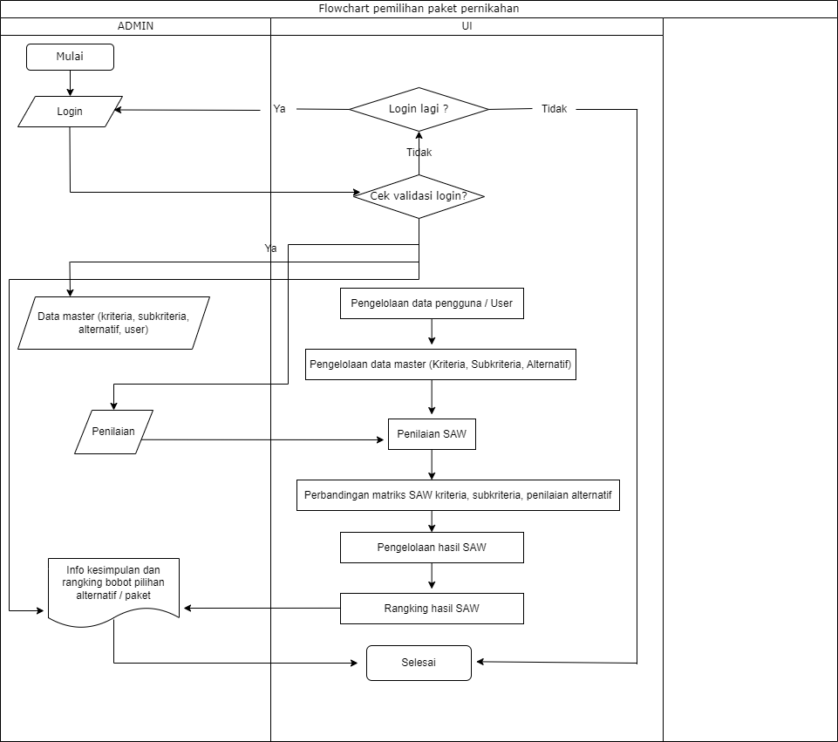

Revisi flowchart sistem hal 63

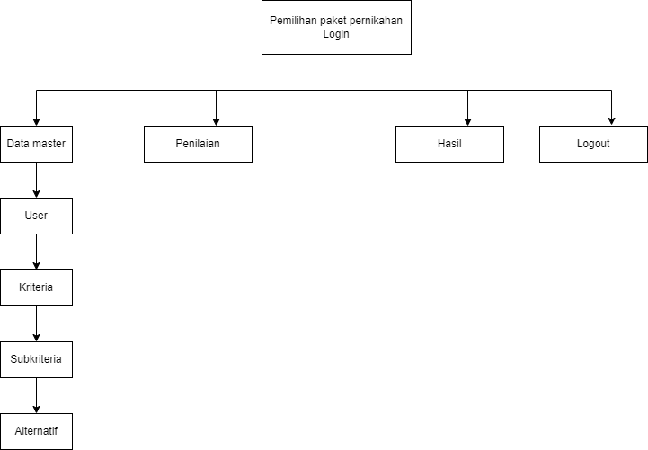

Rancangan menu utama hal 65